AWS Networking Assignment

Task 1: Create One VPC with One Public Subnet and One Private Subnet
Purpose
To create an isolated virtual network with one public subnet for internet-facing resources and one private subnet for internal resources.

Navigation Path
AWS Console
↓
VPC
↓
Create VPC

Configuration
Parameter | Value
VPC Name | VPC-A
CIDR Block | 10.0.0.0/16
Public Subnet | 10.0.1.0/24
Private Subnet | 10.0.2.0/24
Internet Gateway | IGW-A
Public Route Table | Public-RT
Private Route Table | Private-RT

Steps
Step 1
Task
Create VPC
Purpose
Creates an isolated network.
Configuration
Name : VPC-A
CIDR : 10.0.0.0/16

Evidence
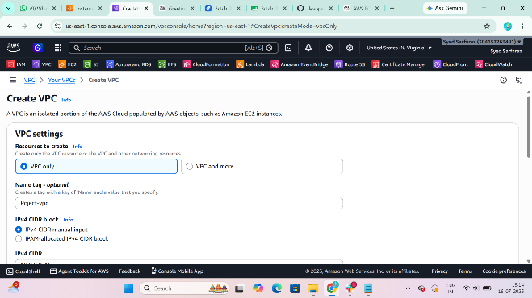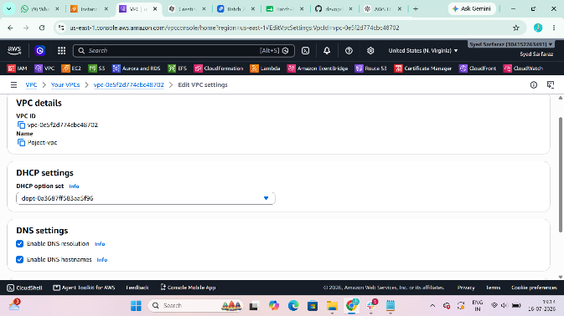
Step 2
Task
Create Public Subnet
Purpose
Hosts internet-facing resources.
Configuration
Name : Public-Subnet-A
CIDR : 10.0.1.0/24
AZ : us-east-1a

Evidence
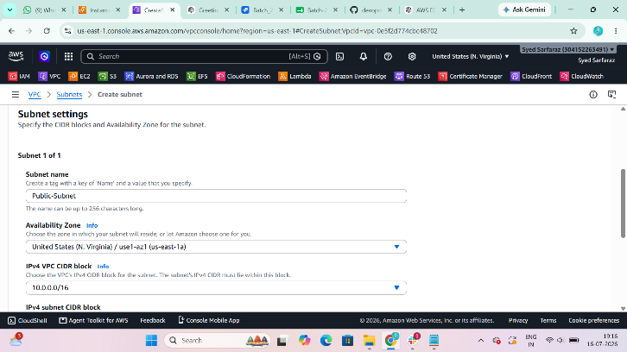
Step 3
Task
Enable Auto Assign Public IP
Purpose
Automatically assigns a public IP to EC2 instances.

Evidence
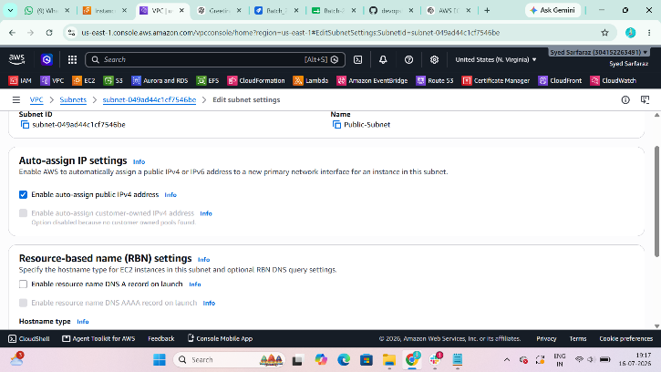
Step 4
Task
Create Private Subnet
Purpose
Hosts backend resources.
Configuration
Name : Private-Subnet-A
CIDR : 10.0.2.0/24
AZ : us-east-1a

Evidence
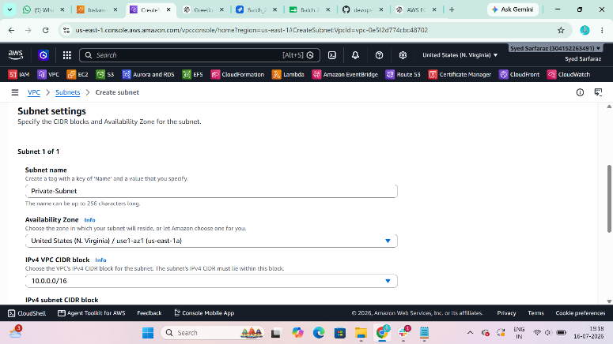
Step 5
Task
Create Internet Gateway
Purpose
Provides internet connectivity.
Configuration
Name : IGW-A

Evidence
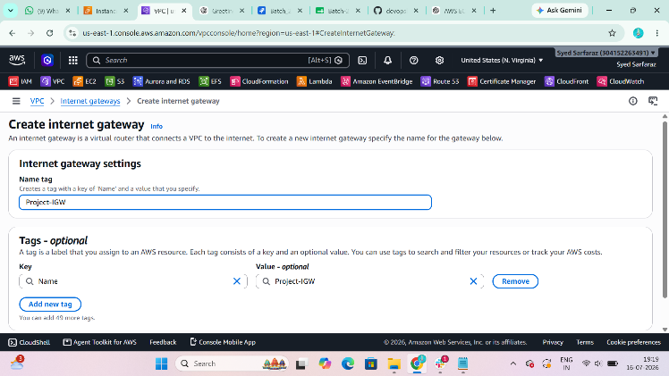
Step 6
Task
Attach Internet Gateway to VPC
Purpose
Allows internet access.

Step 7
Task
Create Public Route Table
Purpose
Controls routing for public subnet.
Route
0.0.0.0/0 → Internet Gateway

Evidence
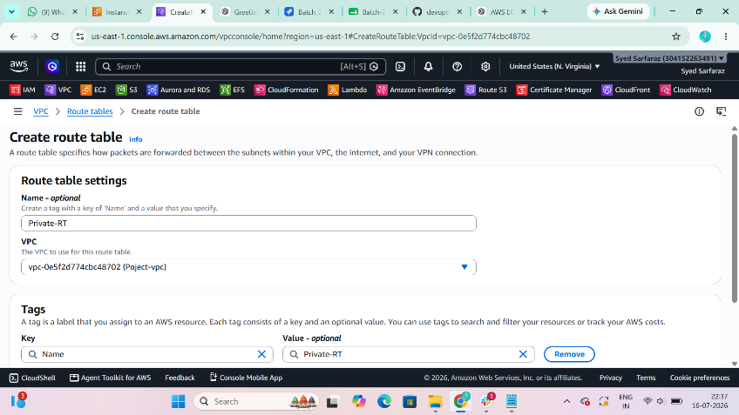
Step 8
Task
Associate Public Subnet
Purpose
Connects Public Subnet with Public Route Table.

Evidence
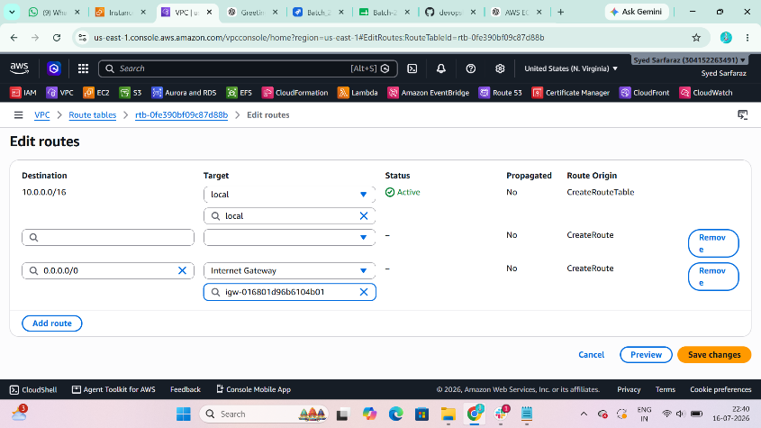
Step 9
Task
Create Private Route Table
Purpose
Controls routing for private subnet.

Evidence
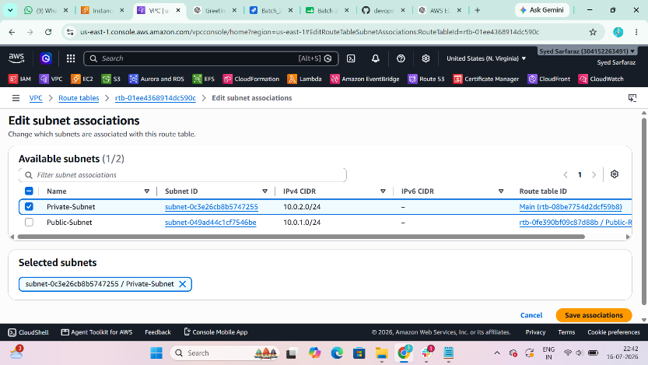
Step 10
Task
Associate Private Subnet
Purpose
Associates Private Subnet with Private Route Table.

Validation
Verify:
- VPC Status = Available
- Public Subnet Created
- Private Subnet Created
- Internet Gateway Attached
- Route Tables Created

Task 2: Enable VPC Peering for Cross-Region
Purpose
To allow communication between VPCs located in different AWS Regions.

Navigation Path
VPC
↓
Peering Connections
↓
Create Peering Connection

Configuration
Parameter | Value
Name | Cross-Region-Peer
Requester VPC | VPC-A
Accepter VPC | VPC-B
Region | Different AWS Region

Steps
Step 1
Task
Create Peering Connection
Purpose
Creates communication between two VPCs.

Evidence
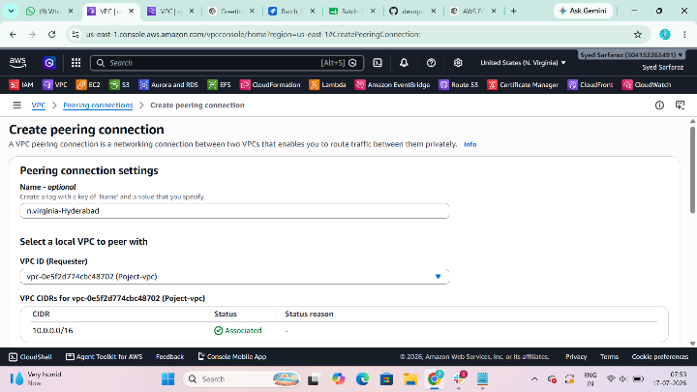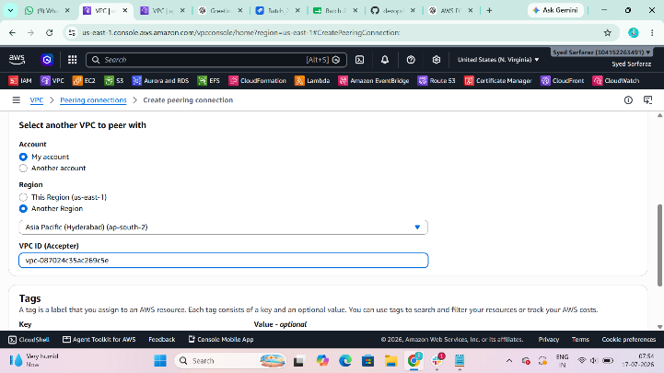
Step 2
Task
Accept Peering Request
Purpose
Completes the peering connection.

Evidence
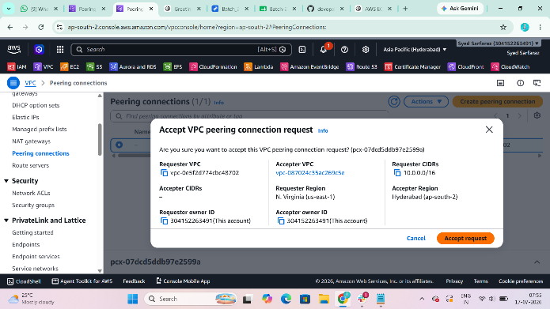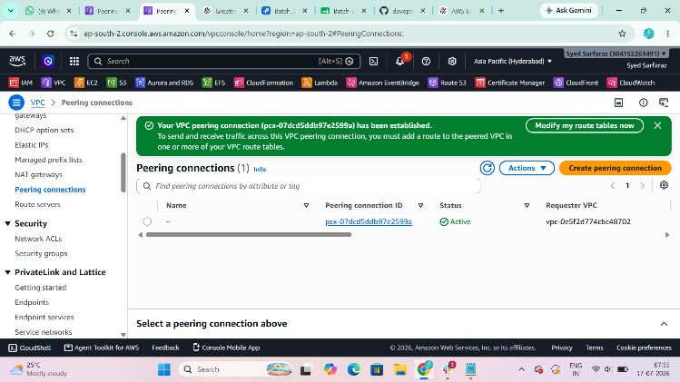
Step 3
Task
Update Route Tables
Purpose
Allows traffic through Peering Connection.
Example
Destination : VPC-B CIDR

Target : Peering Connection

Validation
Verify
Peering Status = Active

Task 3: Enable VPC Peering for Cross-Account
Purpose
To allow communication between VPCs in different AWS accounts.

Navigation Path
VPC

↓

Peering Connections

↓

Create Peering Connection

Configuration
Parameter | Value
Requester | Your AWS Account
Accepter | Friend's AWS Account
Peering Name | Cross-Account-Peer

Steps
Step 1
Create Peering Request

Evidence
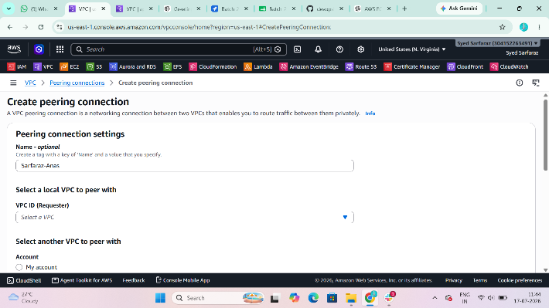
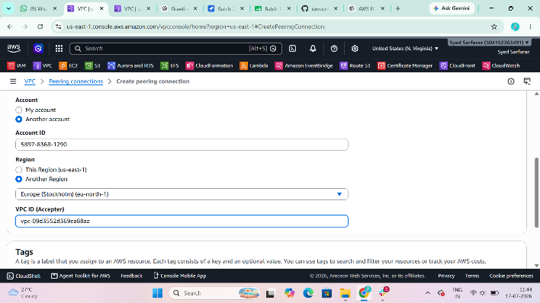
Step 2
Friend Accepts Request

Evidence
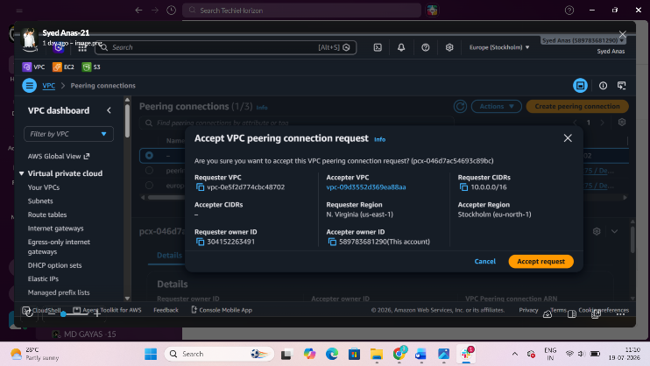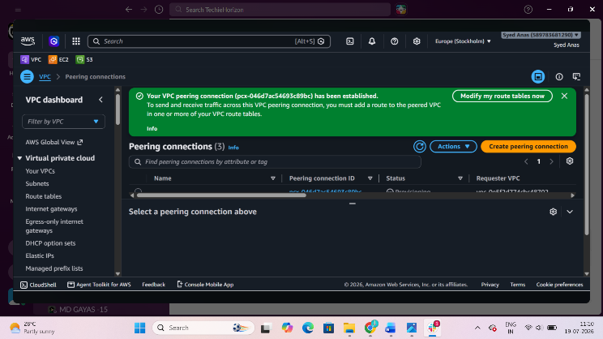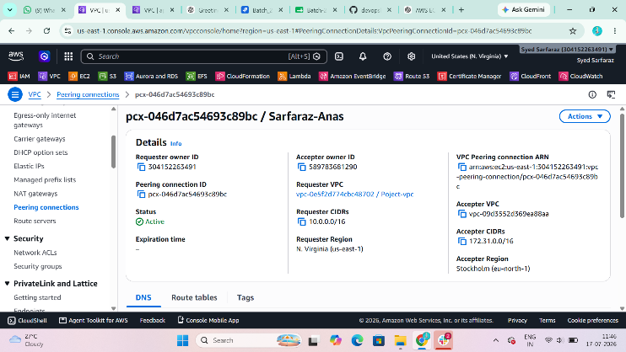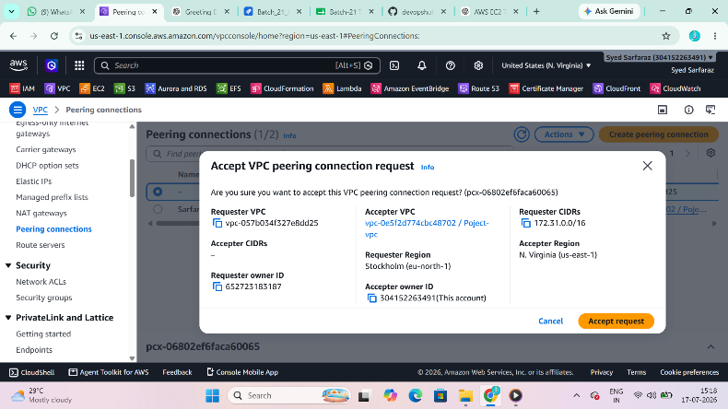
Step 3
Update Both Route Tables

Validation
Status = Active

Task 4: Set Up a VPC Transit Gateway
Purpose
To connect multiple VPCs using a centralized routing hub.

Navigation Path
VPC

↓

Transit Gateways

↓

Create Transit Gateway

Configuration
Parameter | Value
Name | Project-TGW
ASN | Default

Steps
Step 1
Create Transit Gateway

Evidence
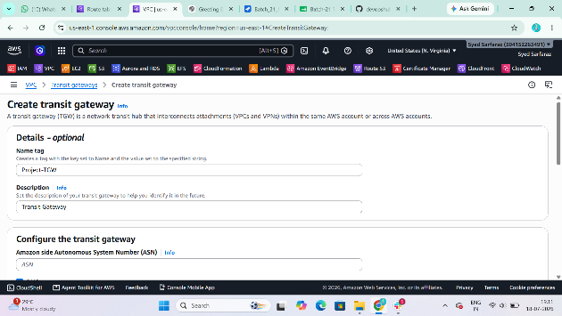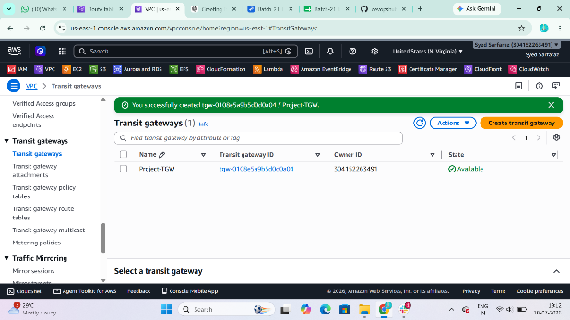
Step 2
Attach VPC-A
Purpose
Connect VPC-A to Transit Gateway.

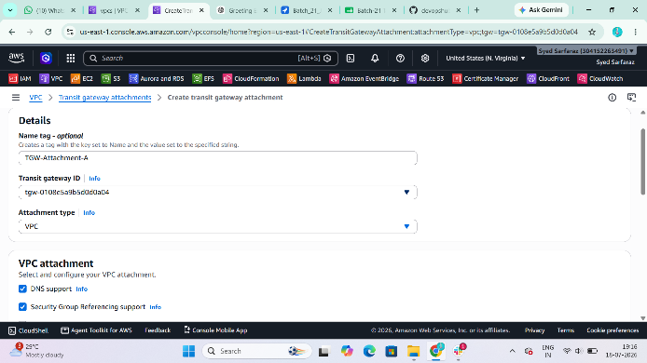

Step 3
Attach VPC-B
Purpose
Connect VPC-B to Transit Gateway.

Evidence
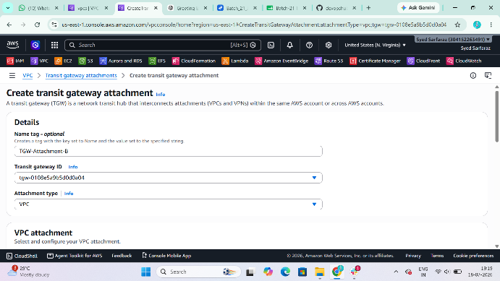
Step 4
Update Route Table of VPC-A
Route
Destination : 192.168.0.0/16

Target : Transit Gateway

Evidence
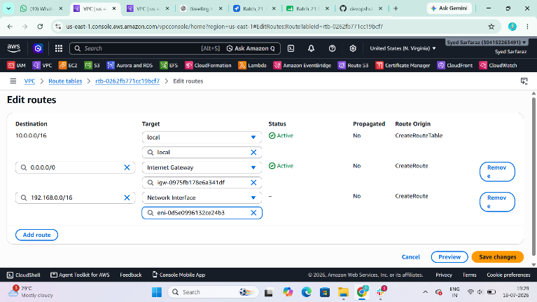
Step 5
Update Route Table of VPC-B
Route
Destination : 10.0.0.0/16

Target : Transit Gateway

Evidence
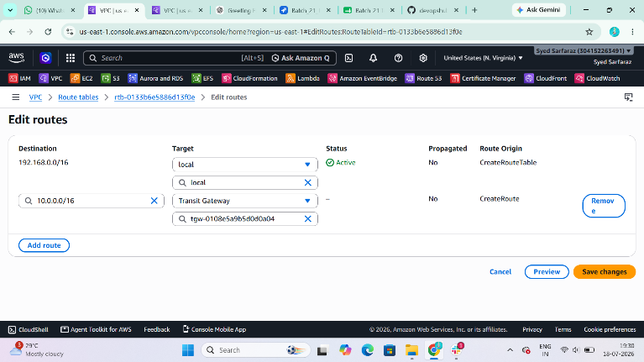
Step 6
Launch EC2 Instances
Purpose
Verify connectivity.

Evidence
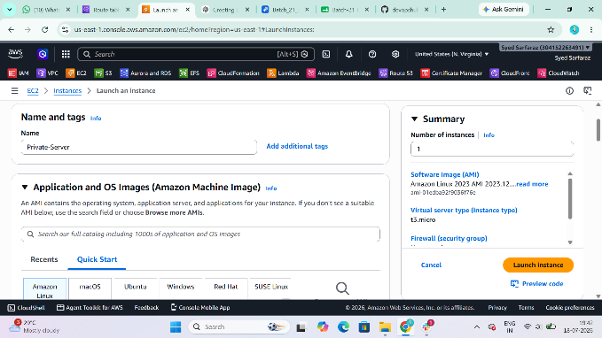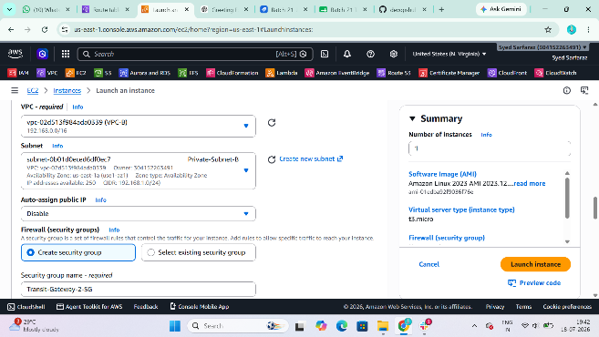

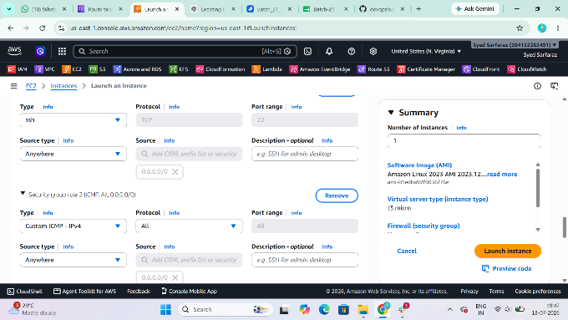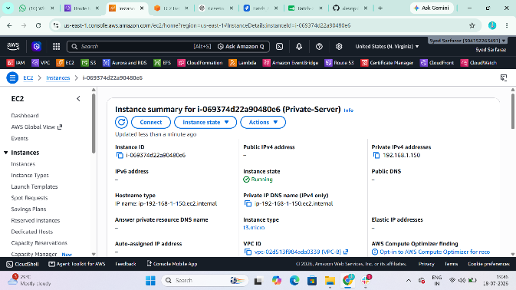

Step 7
Ping Between EC2 Instances
Command
ping <Private-IP>
Purpose
Verify Transit Gateway connectivity.

Evidence
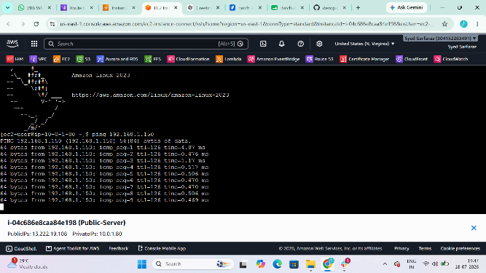
Validation
Ping Successful

Task 5: Set Up a VPC Endpoint
Purpose
To securely access Amazon S3 from a private subnet without using the Internet Gateway or NAT Gateway.

Navigation Path
VPC
↓
Endpoints
↓
Create Endpoint

Configuration
Parameter | Value
Service | S3
Endpoint Type | Gateway
VPC | VPC-B
Route Table | Private-RT

Steps
Step 1
Create S3 Gateway Endpoint

Evidence
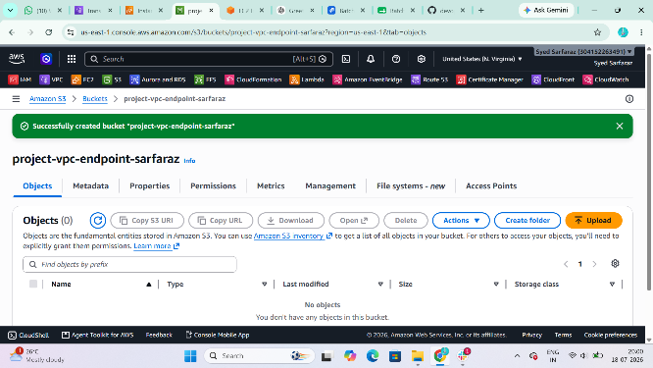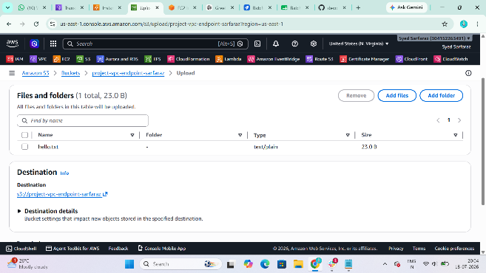

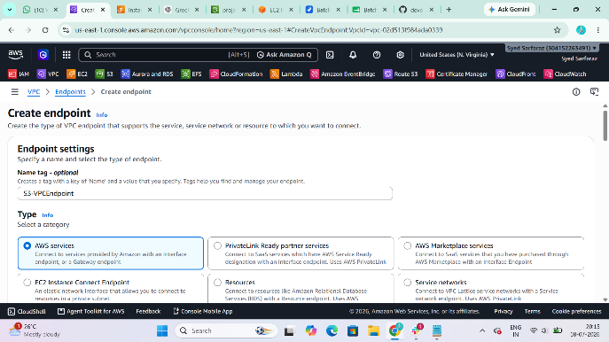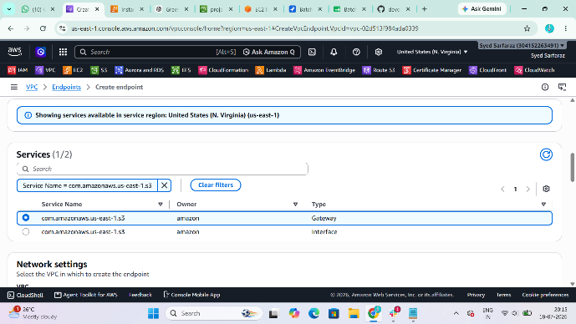

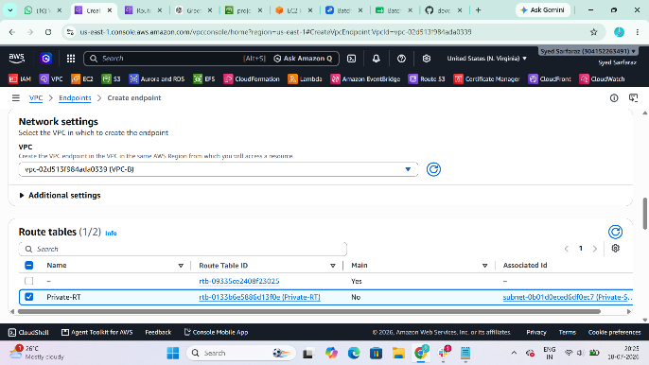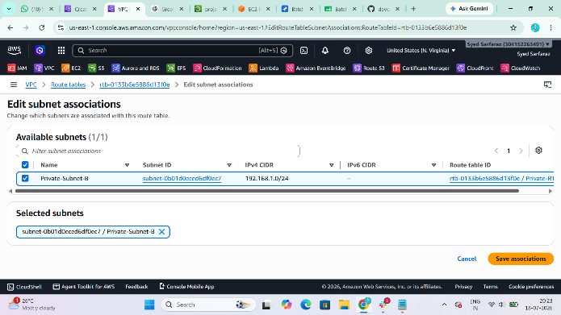

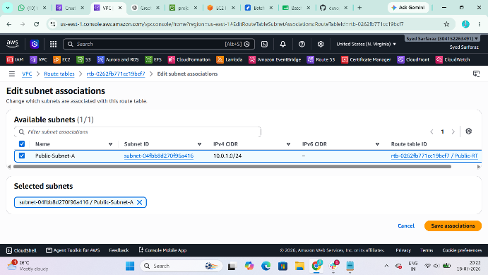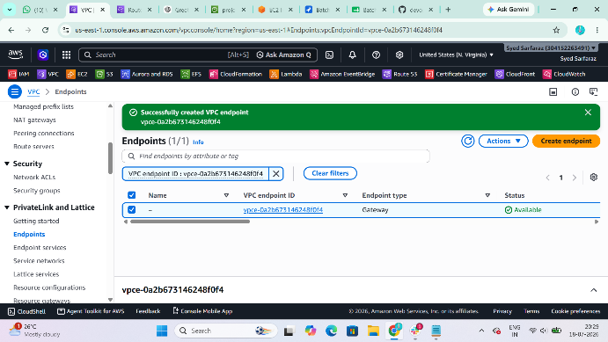

Step 2
Verify Route Table
Purpose
Confirm Prefix List route is added automatically.

Evidence
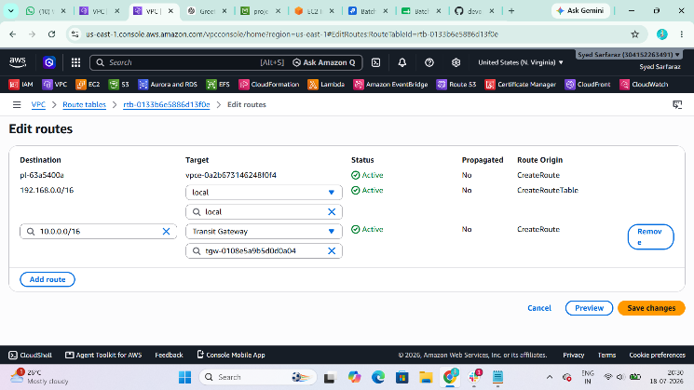

Step 9: Attach an IAM Role (Important)
Without S3 permissions, the AWS CLI cannot list or access your bucket even if the VPC Endpoint is configured correctly.
- Go to IAM → Roles.
- Create or use a role with the AmazonS3ReadOnlyAccess policy (or a more specific S3 policy).
- Go to EC2 → Instances.
- Select your private EC2.
- Choose Actions → Security → Modify IAM role.
- Attach the role and save.

Evidence
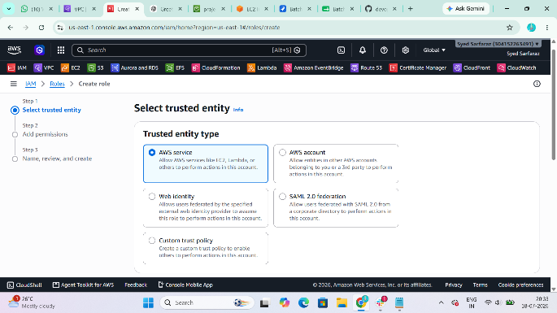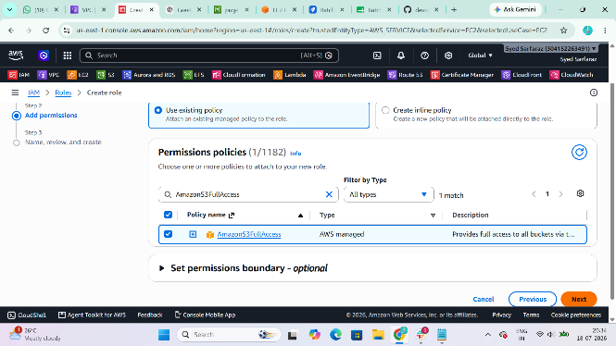
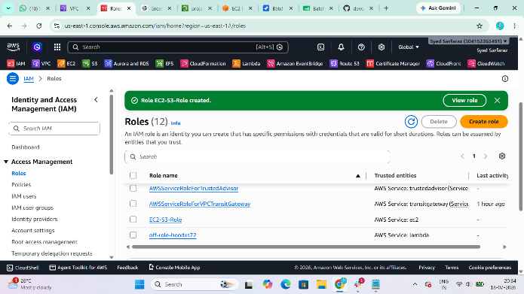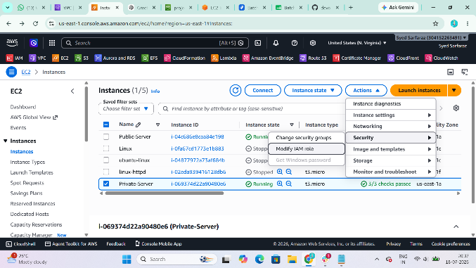

Step 3
Launch Private EC2
Purpose
Test S3 access.

Evidence

Step 4
Connect to Private EC2
Command
ssh -i task.pem ec2-user@<Private-IP>
Purpose
Access the private EC2 through the bastion/public EC2.

Evidence
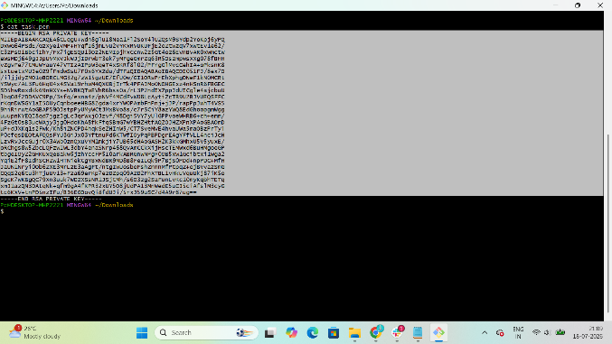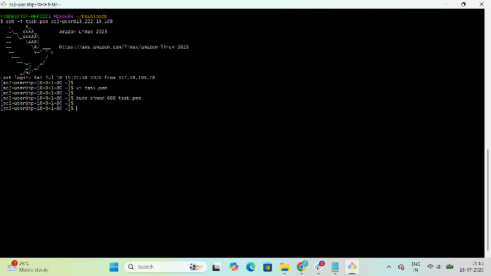

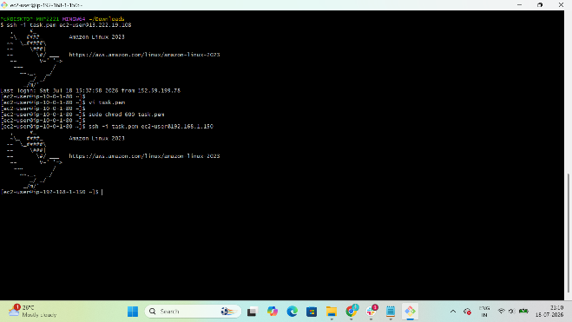

Step 5
Check AWS CLI
Command
aws --version
Purpose
Verify AWS CLI is installed.

Evidence
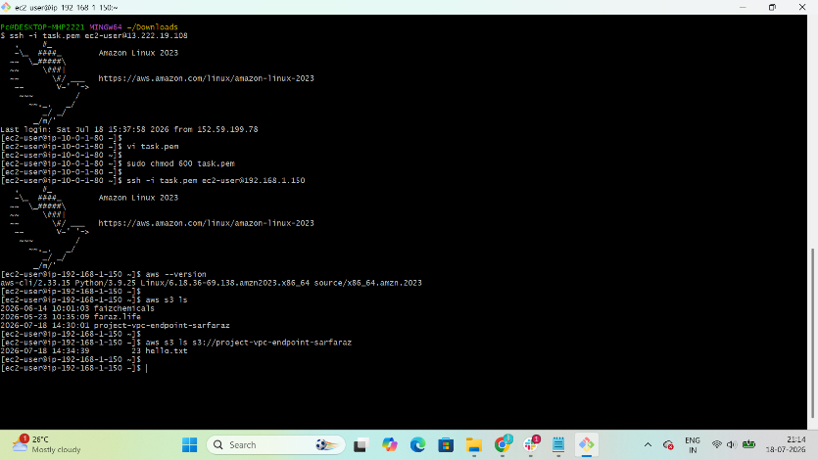
Step 6
List S3 Buckets
Command
aws s3 ls
Purpose
Verify the private EC2 can access S3 through the VPC Endpoint.

Evidence
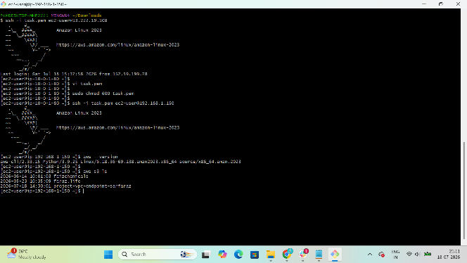
Step 7
List Specific Bucket
Command
aws s3 ls s3://project-vpc-endpoint-sarfaraz
Purpose
Verify access to the specific S3 bucket via the VPC Endpoint.

Validation
Verify:
- Endpoint Status = Available
- Route Table contains:
pl-xxxxxxxx → vpce-xxxxxxxx
- aws s3 ls executes successfully from the private EC2 without internet access.

